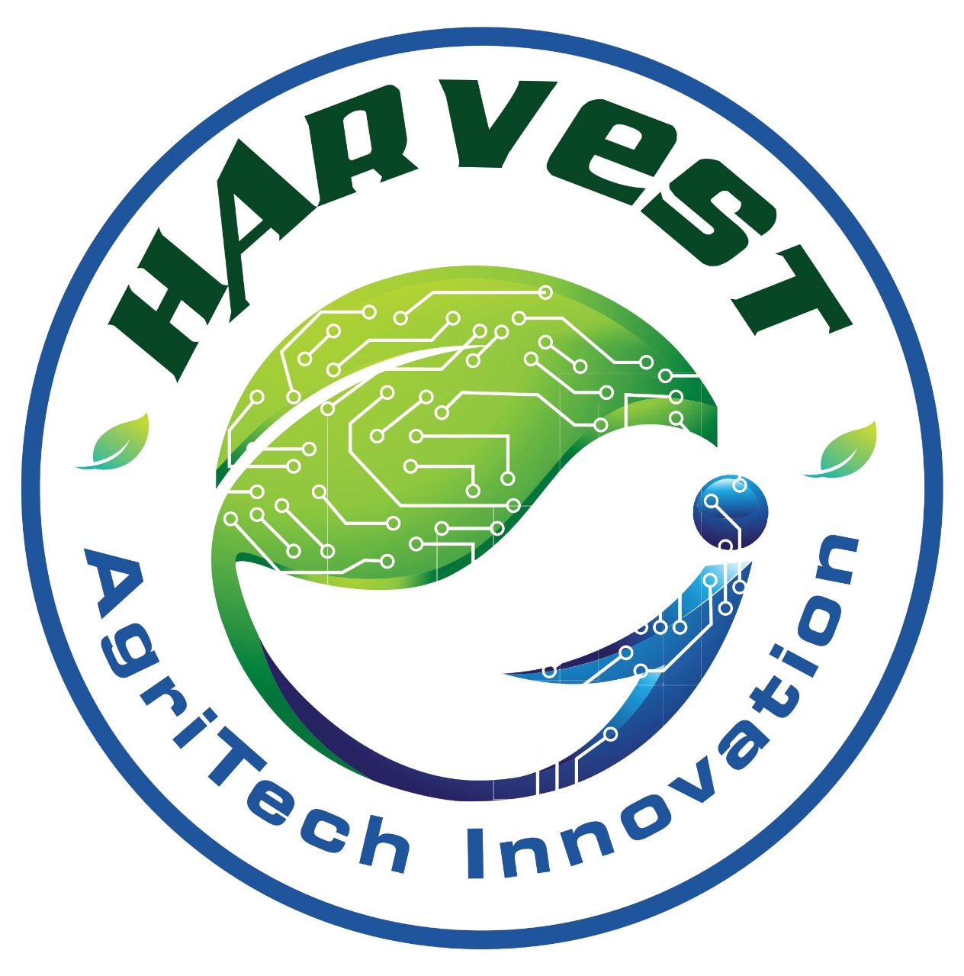

**SHELEADS 2.0 Rulebook**

**1. About the Hackathon**

SheLeads 2.0 is a 24-hour national-level women-centric hackathon designed to empower women innovators to build technology-driven solutions for real-world societal challenges.

The hackathon focuses on fostering leadership, creativity, collaboration, and rapid prototyping in an inclusive environment. Participants will work in teams to ideate, build, and present impactful solutions across multiple social-impact technology tracks, evaluated by expert mentors and jury members from industry and academia.

**2. Team Composition**

* Teams must consist of **2-4 members**.
* The hackathon is open for **national-level participation**, including **Presidency University students**.
* Cross-institution and interdisciplinary teams are allowed and encouraged.
* Each participant can be a part of **only one team**.
* **No changes to team members will be allowed after registration.**

**Mandatory Women Leadership Rule**

* Every team must include **at least one female participant**.
* The **Team Leader must be a female participant** (mandatory).
* The female team leader will be the **official point of contact** for all communications.
* Any team failing to comply with this rule will be **disqualified**.

**3. Registration & Selection Process**

**A. Registration**

* Teams must register exclusively through the **Unstop platform**.
* Registration is open for **national-level participation**.
* Each team must upload a project proposal using the **official PPT template**.
* Only **one submission per team** is permitted.
* Teams must select **one track** to submit their idea under.
* Teams will **not be allowed to change their track or idea** after submission.

**B. Participation Limit**

* The hackathon will host approximately **200 participants**, which corresponds to around **50 teams**.

**C. Selection & Shortlisting**

A total of **50 teams** will be shortlisted, with **10 teams per track**, based on:

* Innovation & Originality
* Relevance to the chosen track
* Practical feasibility
* Social or technological impact
* Clarity of the proposal

All shortlisted teams will receive an email confirmation and will be invited for the offline 24-hour hackathon round. Teams who are not selected will also be notified accordingly.

**4. Tracks**

She Leads 2.0 includes the following **5 social-impact technology tracks**:

**I. EmpowerAbility**

Technology that empowers every ability.

Sub-Tracks:

• Assistive AI Systems

• Speech, Vision & Multimodal Technologies

• Inclusive UX/UI Design

• EdTech & Language Accessibility Tools

**II. SheShield: Smart Safety & Empowerment**

Innovations that protect and empower women.

Sub-Tracks:

• Safety & SOS Applications

• Emergency Response & Geo-Intelligence

• Smart Wearables for Protection

• Legal Awareness & Community Support Platforms

**III. AgriRise: Rural Intelligence Revolution**

Smart innovation for rural transformation.

Sub-Tracks:

• AI-Powered Smart Farming

• IoT & Crop Monitoring Systems

•Supply Chain & Market Optimization

• Farmer Advisory & Decision Support Systems

**IV. CreateX: AI for Digital Expression**

Reimagining media, storytelling & immersive experiences.

Sub-Tracks:

• AR/VR & Immersive Platforms

• AI-Driven Creative Media

•Generative & Interactive Content

• Next-Gen UX/UI & Experience Design

**V. LeadHer: FinTech & Social Impact Innovation**

Building financial power & leadership ecosystems.

Sub-Tracks:

• Women-Centric FinTech Solutions

• Entrepreneurship & Startup Platforms

• Skill Development & Career Tech

• Policy, Governance & Impact Analytics

**5. Event Schedule & Logistics**

**A. Venue & Access**

* The hackathon will be conducted **offline at Presidency University, Bengaluru**.
* Participants will not be allowed to leave the campus during the hackathon for safety and integrity reasons.
* Movement outside designated hackathon zones is strictly prohibited unless authorized by organizers for emergencies.

**B. Facilities Provided**

* Wi-Fi access for all participants
* Power backup
* Secure working spaces and designated rest zones

**C. Food & Refreshments**

Organizers will provide:

* Day 1: Snacks, Lunch, Dinner, Midnight snacks
* Day 2: Breakfast, Lunch, Beverages/Snacks

Participants may carry small comfort items (blankets, cushions, eye masks, etc.) for the overnight stay.  
All belongings may be checked upon entry, and the organizers will not be responsible for loss or damage to personal items.

**6. Project Development Rules**

* Teams may brainstorm and plan before the event.
* However, all implementation (coding, design, hardware assembly) must begin **only after the hackathon officially starts**.
* Both **software and hardware** projects are allowed.
* Use of open-source libraries, APIs, and public datasets is permitted with proper attribution.
* Plagiarism, copying, or submitting previously completed work is strictly prohibited.
* Each team must submit:
  + A **GitHub repository link** (or equivalent)
  + A working prototype/demo
  + (Optional) a demo video or final presentation

Submissions must be completed before the deadline at the end of the 24-hour period.  
Late submissions will not be accepted.

**7. Mentorship & Support**

* Teams will receive **on-site mentorship** and **technical assistance** during the hackathon if and when needed.
* Mentors will be available to provide guidance on design, architecture, strategy, or debugging.
* Organizers will also assign **support volunteers** to assist with logistics and queries.

**8. Judging Process**

* A panel of **5 expert judges** (one per track) from industry will evaluate all the teams in the respective track in each of the evaluation rounds and during final submission.
* A **live pitching/demo round** will be held after the build phase, where the top team from each track will present their solution to all the jury members.
* Judges’ decisions are **final and non-negotiable**.

**Judging Criteria:**

| **Evaluation Aspect** | **Weight** |
| --- | --- |
| Innovation & Creativity | 25% |
| Technical Complexity | 25% |
| Relevance to Track | 10% |
| Implementation & Functionality | 30% |
| Presentation & Communication | 10% |

**9. Awards & Recognition**

**Total Cash Prize Pool**: ₹60,000

**Breakdown:**

1st Place: ₹30,000

2nd Place: ₹20,000

3rd Place: ₹10,000

**Additional Perks:**

* Winners will be announced during closing ceremony
* **Certificates** will be provided for all participants
* Opportunities to **network** with judges, mentors, and guests for potential **incubation/follow-up support**

**9. Code of Conduct & Disqualification**

SHELEADS 2.0 is committed to providing a respectful, safe, and fair environment for all.

**Expected Behaviour:**

* Maintain professionalism and respect with peers, mentors, and staff.
* Follow all University and Hackathon rules.
* Cooperate with volunteers and organizers at all times.

**Prohibited Behaviour:**

* Harassment, discrimination, or inappropriate conduct
* Use of **alcohol, tobacco, or banned substances**
* Leaving the venue without approval
* **Plagiarism, cheating, or code misrepresentation**

**Consequences:**

* **Immediate disqualification**
* Removal from campus
* Notification to home institution (if required)

Organizers reserve the right to investigate and enforce action on any misconduct.

**10. Intellectual Property & Promotion**

* All participants **retain full ownership** of their projects and intellectual property.
* Organizers will not claim any commercial rights or profits.
* By participating, teams grant the organizers **non-exclusive rights** to:
  + Publicly display winning projects, team names, or visuals for **event promotion** (e.g., website, social media, brochures).
* **Only winning project titles** will be published post-event. Project code/content will not be shared without explicit permission.

**Final Notes & Compliance:**

* The event schedule, rules, logistics are subject to change at discretion of organizers.
* All official communication will be sent through **email and WhatsApp** only.
* By registering, each participant agrees to:
  + Abide by all terms listed in this handbook
  + Follow the instructions of the event coordinators
  + Accept all final decisions made by organizing committee and judging panel

**For Queries & Support:**

* **Email**: [harvest-club@presidencyuniversity.in](mailto:harvestclub.presidency@gmail.com)